Collatz Decoded

Part I
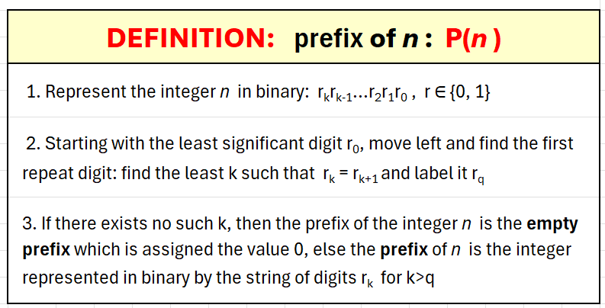
Our ideas begin with these definitions…
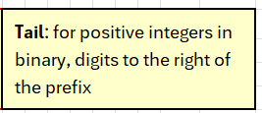
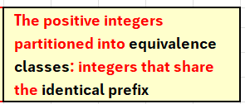
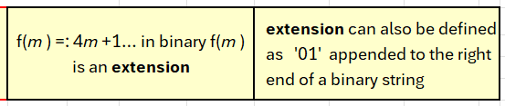

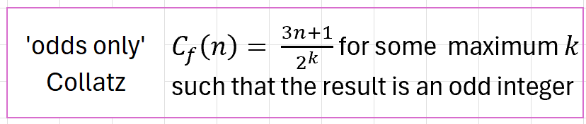

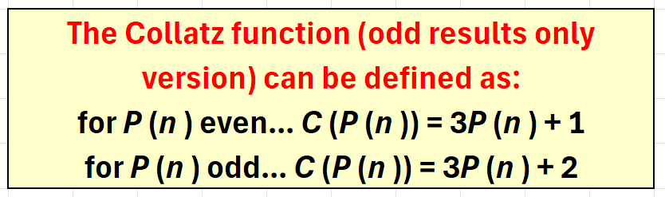
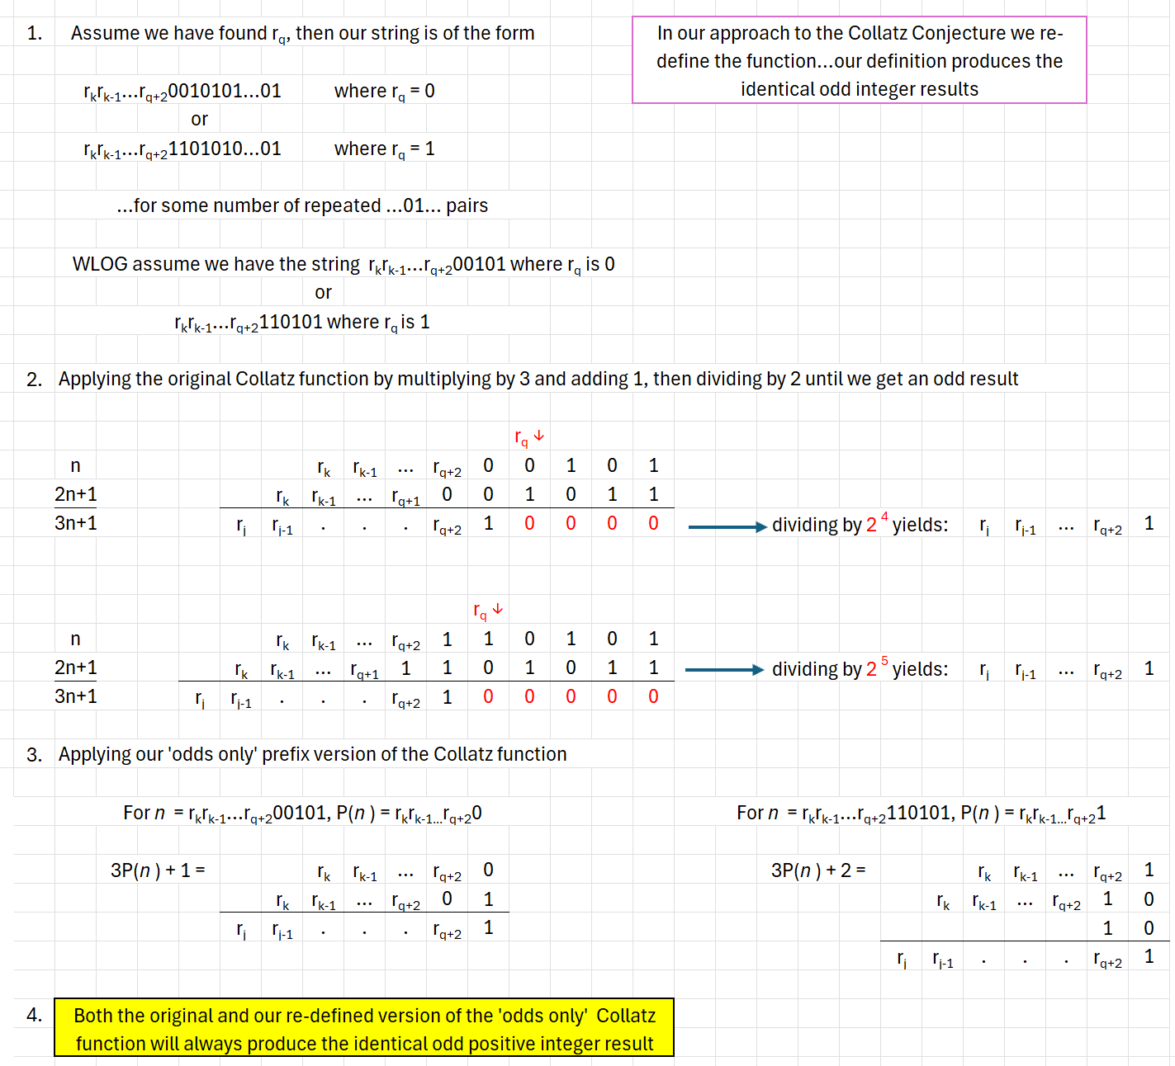
We observe that with these definitions the original ‘odds-only’ version of the Collatz function C_{f} can be re-defined in terms of ‘prefix’…
Since every member of a given prefix equivalence class will by the original Collatz function (C_{f}) produce the identical first odd integer result and thus the identical prefix class result, a proof of the conjecture can be achieved by consideration of the sequence of prefix classes alone. Proving that we can specify the sequence of classes determined by the Collatz function for every odd positive integer is sufficient as a foundation for proof that every integer will eventually descend to the fixed cycle at 1.
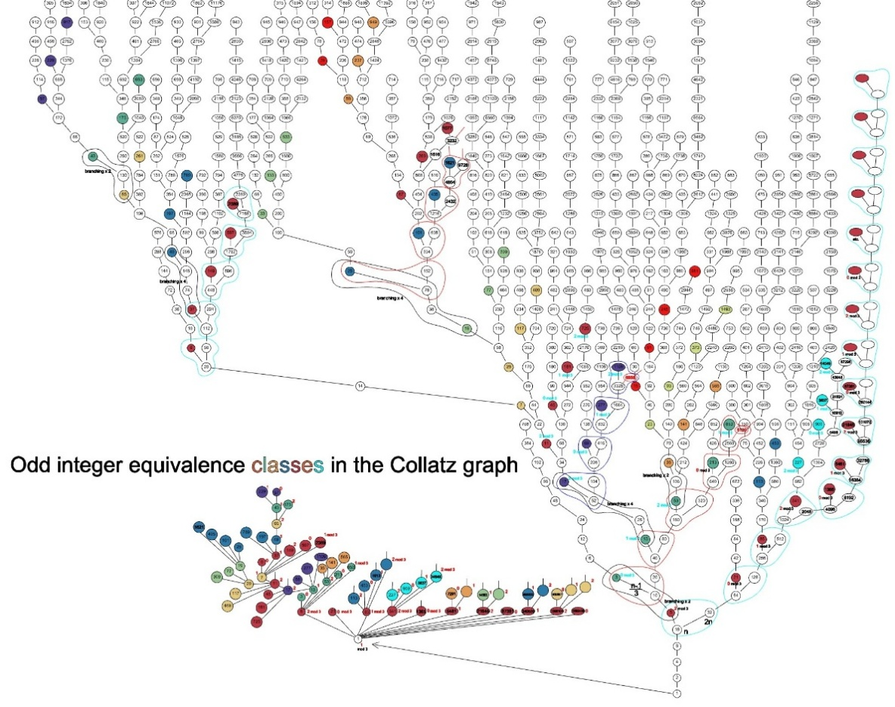

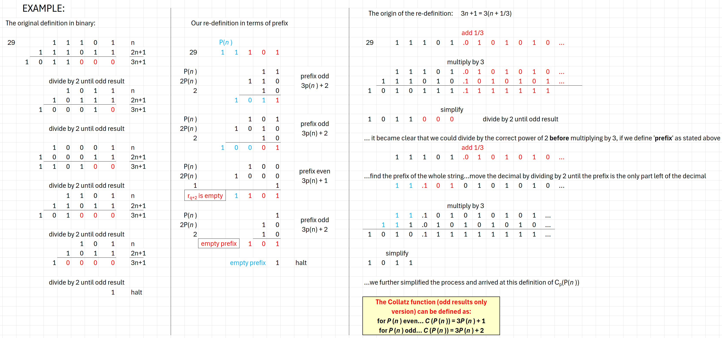
We view the Collatz function as operating on infinite prefix equivalence classes of odd positive integers…as an affine function from one prefix class to another. Our reparameterization of the Collatz function provides a relative orientation between prefix classes producing a total order on the set of prefix classes. Relative to a given odd positive integer we can establish an orientation of ‘upward’ and ‘downward’ between classes:
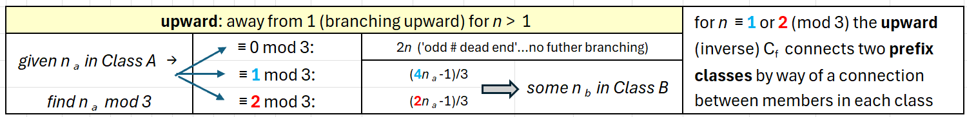
- ‘Upward’ from a given odd positive integer points to a whole infinite class of values in the single, unique prefix class all of whose members return that given odd positive integer as a result of the application of the original Collatz ‘odds-only’ function (C_{f}).
- Though strictly speaking C_{p} operates on prefix classes, upward can be described as ‘1 to many’.
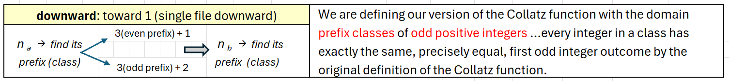
- An odd positive integer determines a class by way of its prefix. We define a class B as ‘downward’ from an infinite class A whose members return a single odd positive integer in that class B as the result of applying the rule …
- ‘Downward’ produces a sequence of classes and can be described as ‘many to 1’:
- Individual members of a class are related by the extension function f(m) = 4m+1…each such member has unique upward branching.
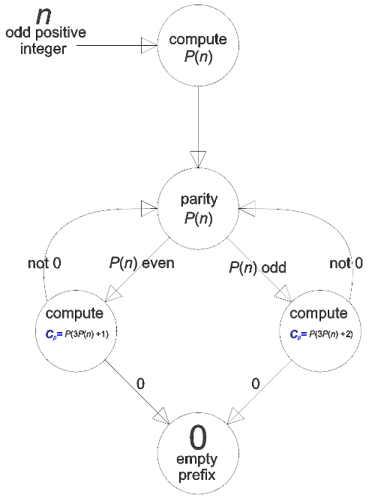
- ‘Downward’ is a cascade through prefix classes by way of an affine function applied to integers as prefixes. The downward C_{p} connects individual integers by operating on the prefix that determines a class.
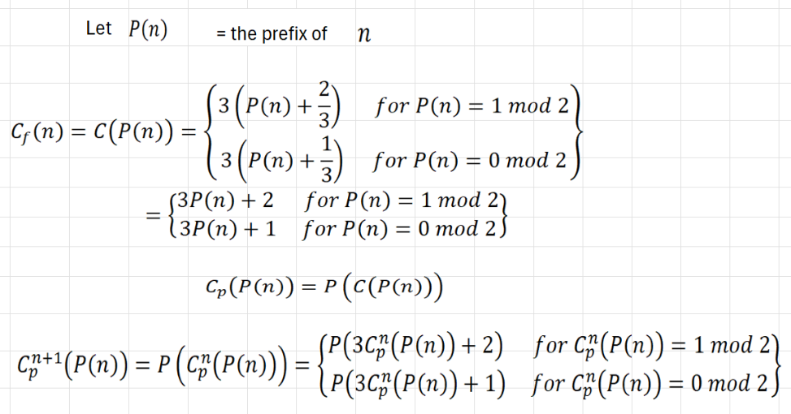
The looping back to ‘parity’ produces an order on prefix classes
The order of operations in the Collatz function C_{p} (P(n)) = P(C (P(n))) determines a strict hierarchy between integers in three distinct roles.
- As n, an integer in counting order
- As P(n), the prefix of n
- As P(C (P(n))), the prefix of the odd integer result of applying the Collatz function to n
The Collatz function reorders the integers as prefixes in an order distinct from counting order.
All n that are multiples of 3 are connected to exactly 1 other integer. Those n ≡ 1 or 2 mod 3 are connected to exactly one other integer ‘up’ and one other integer ‘down’. The function connecting classes is determinate and affine.

Part II
The structures described in Part I have immediate application to producing a coordinate system on the Collatz results.
Because both prefixes and class position can be ordered in the usual counting order, we can represent every odd integer uniquely by just two coordinates: (prefix, class position). This coordinate scheme produces a total order on the odd positive integers distinct from counting order or the order imposed by branching in the Collatz graph. 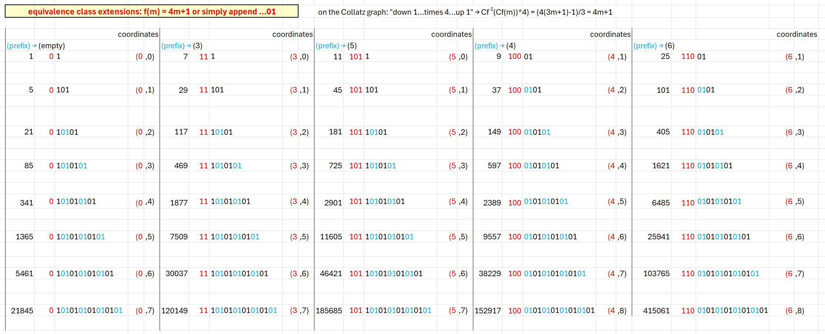
If we label the edges between two integers in the odds-only Collatz graph with the coordinate pair that applies to the upward element, we can then consider the graph directed. 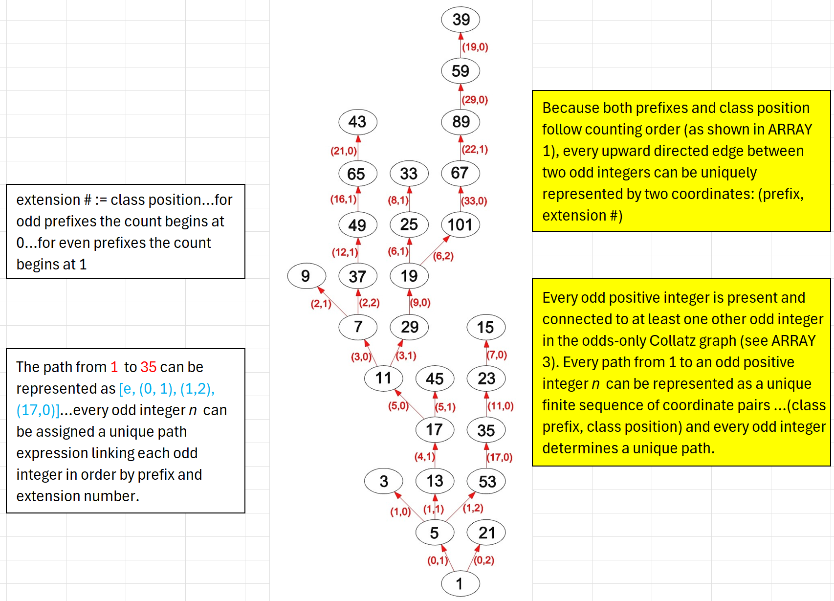
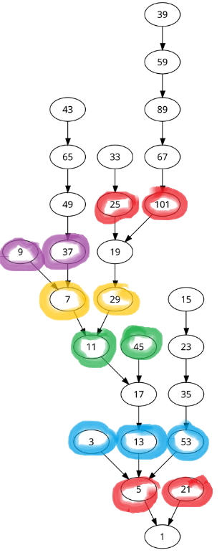
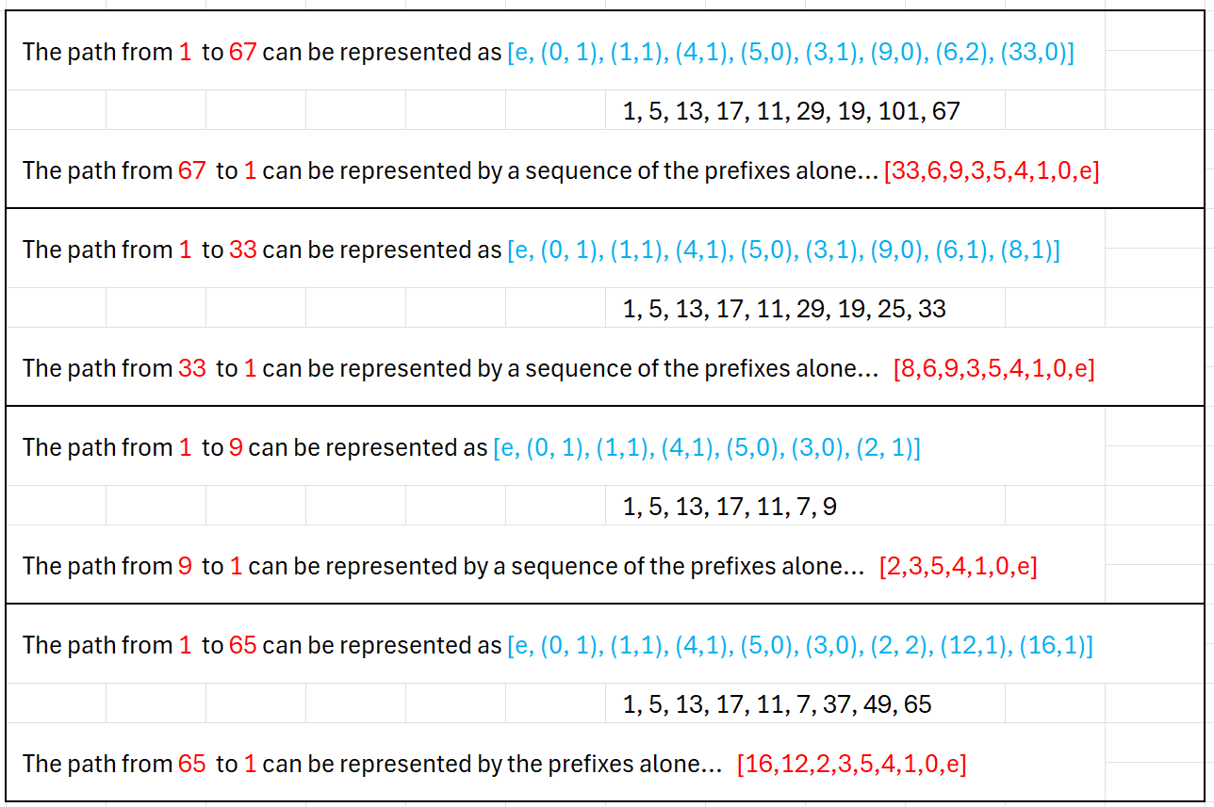
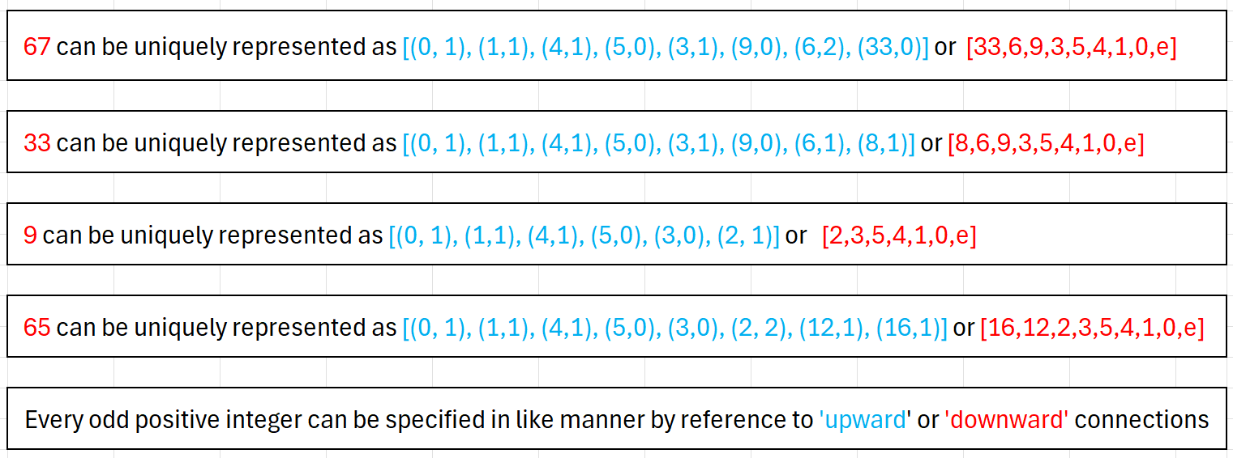
The Collatz function produces a total order on the odd positive integers.
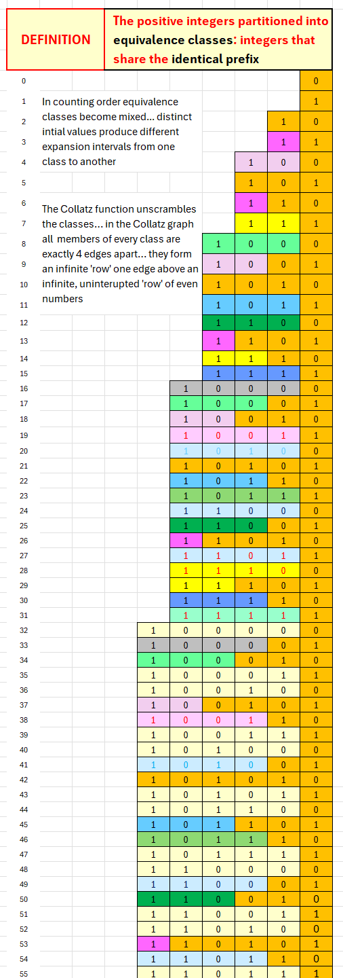

Part III
We construct three arrays founded on the integers expressed in binary in counting order. 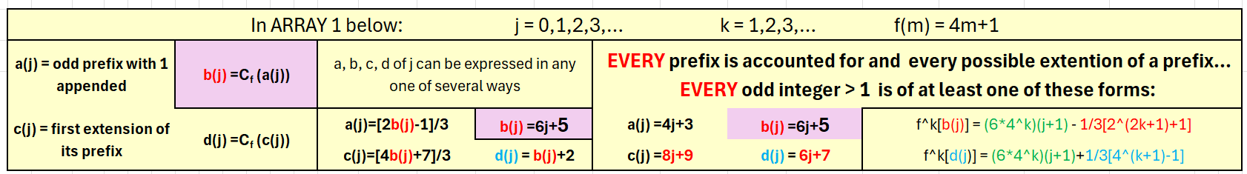
ARRAY 1 shows the results of applying the Collatz function to the odd positive integers determined by each prefix with prefixes in counting order. The ARRAY can be extended without limit. The result of applying the Collatz function to prefixes in counting order is a reordering of prefixes…
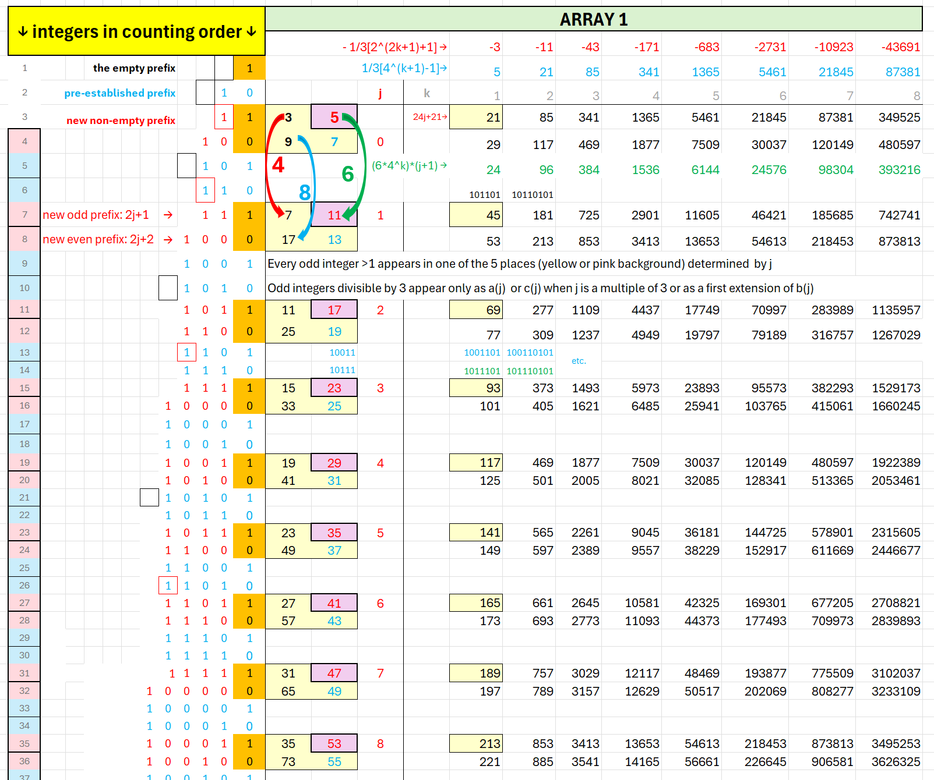
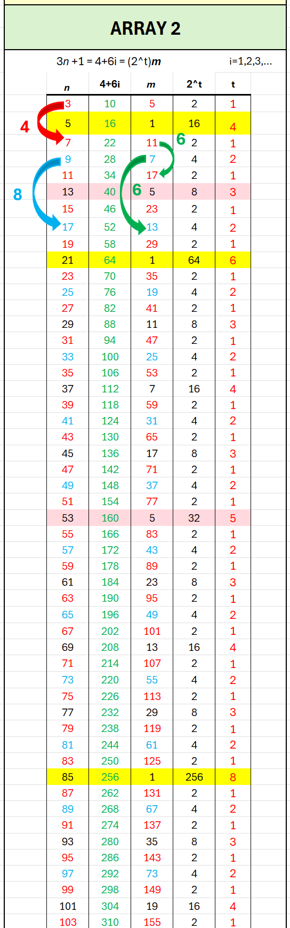
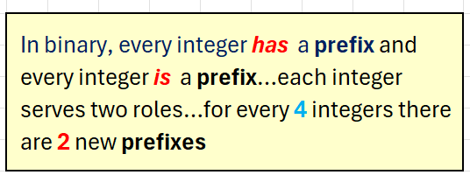
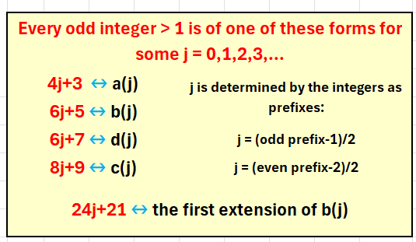
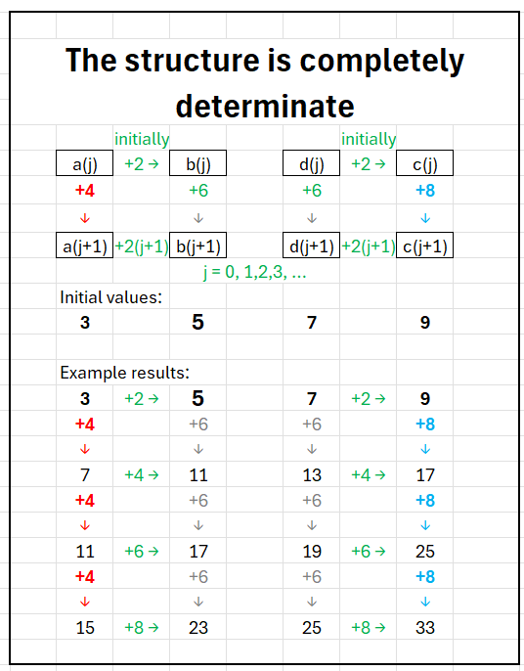

ARRAY 2 uses the information from ARRAY 1 and arranges the branching of the Collatz graph in counting order and can be extended without limit…
Branching in the Collatz graph is always at an even number of the form 3n+1 = 4+6i for n odd and i = 1, 2, 3,…
No application of the 3n+1 part of the Collatz function can result in a multiple of 3….numbers in black in column m are in a previously established prefix class…Every odd number is present in ARRAY 2 in column n.
Rows with m = 1 are determined by elements in prefix class 0...Between rows with m = 1 the t column is an initial segment of the 'ruler function' sequence.
The rows with m = 1 start at 5 and occur at every odd integer that is an extension in the 0-prefix class.
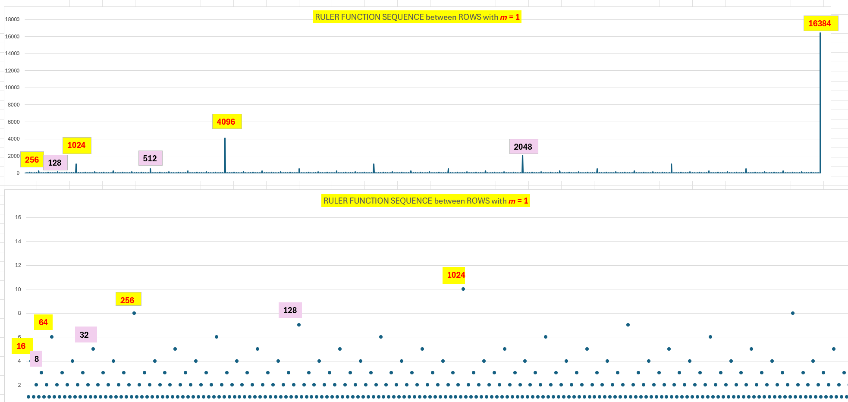
The inductive structure of ARRAY 3 shows that every odd integer can be found in ARRAYs 1, 2 and 3…
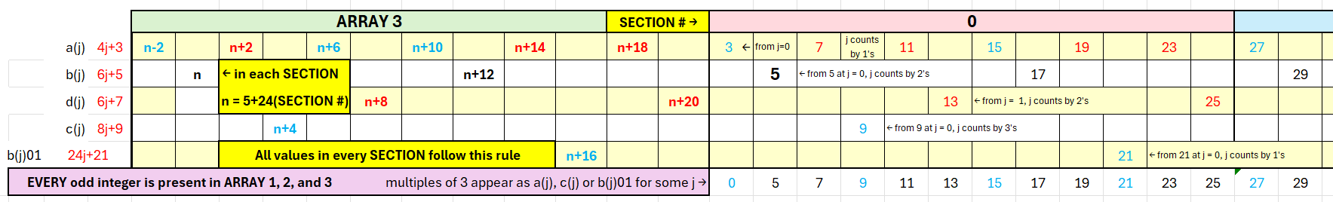
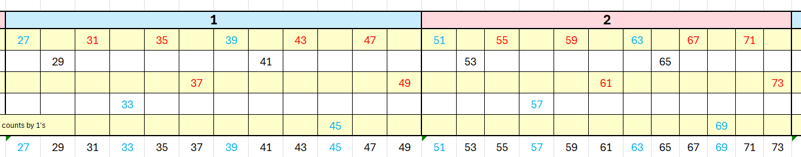
Each SECTION of ARRAY 3 consists of 12 odd integers. As constructed, the values in each SECTION depend on the first b(j) value in the SECTION as indicated…this ARRAY can be extended without limit.
The fact that every odd integer has a precise location in the ordered ARRAYs 1, 2, and 3 shows that every odd positive integer can be given a unique set of coordinates according to the scheme described in Part II.

Part IV
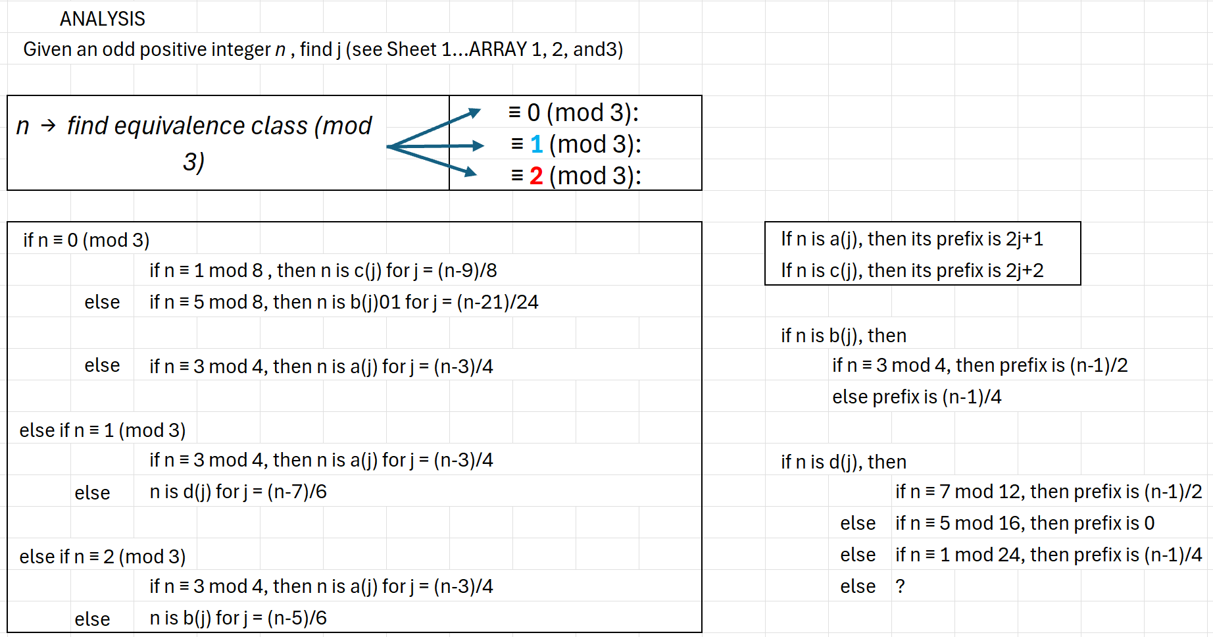
The Collatz function reorders the integers as prefixes. If we form ordered pairs of input prefix in counting order and output prefix as ordered by the Collatz function we see this structure…

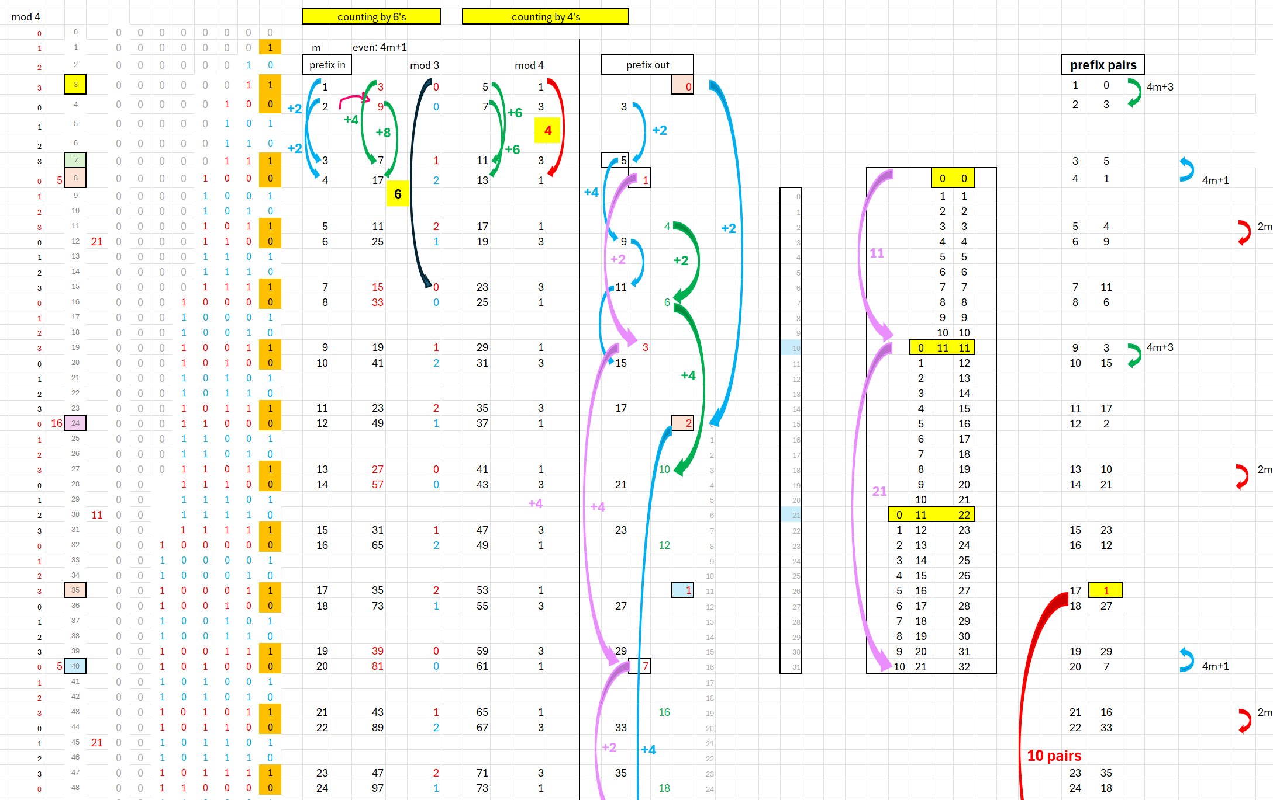
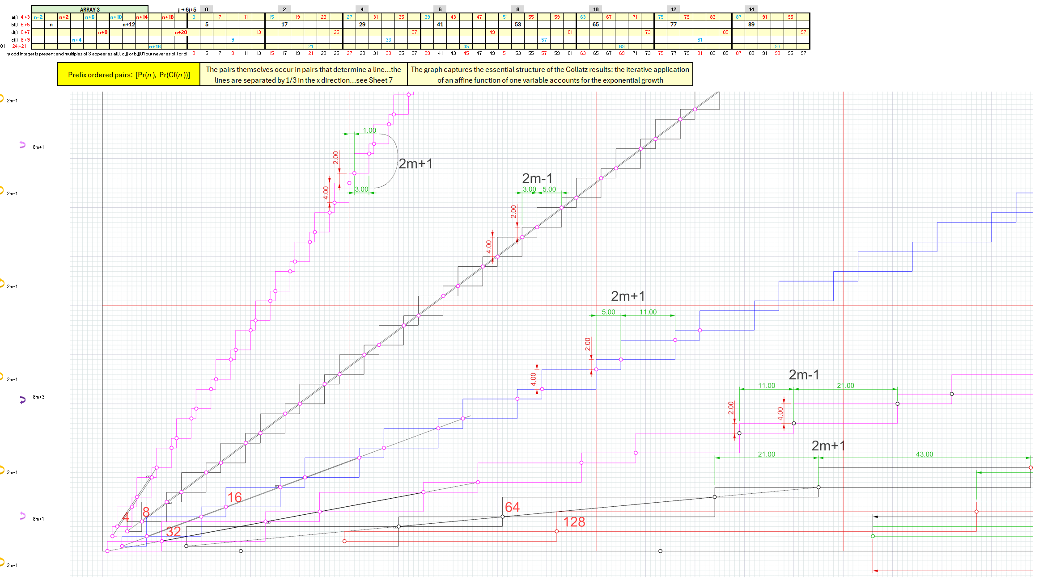
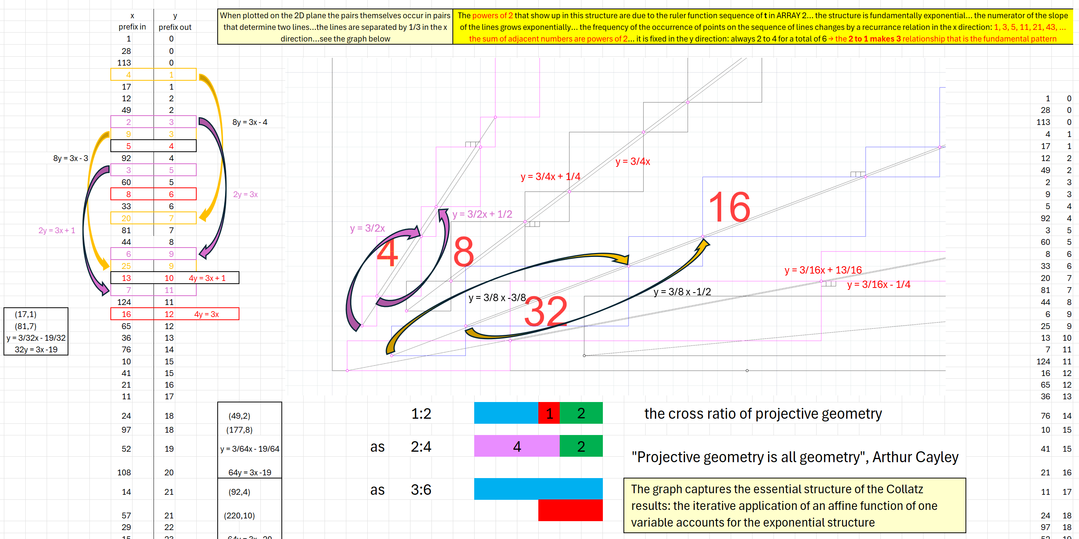

Part V
In terms of our odds-only, prefix class view as presented via ARRAYs 1, 2, and 3, the original Collatz Conjecture makes these claims
- Every odd integer can be specified with a unique finite sequence of ordered pairs.
- For every odd integer its set of coordinates will begin with (0,1) and end with (its prefix, # of extensions). The sequence of first coordinates indicates its downward path through the Collatz graph.
- Every path from an odd positive integer descends (in the sense defined by the function C_{p} (P(n)) = P(C (P(n))) as explained in Part I) to the class with the empty prefix.
Our argument…
- C(P(n)):=
  - for P(n) even... C(P(n)) = 3P(n) + 1
  - for P(n) odd... C(P(n)) = 3P(n) + 2
- We define a ‘downward connection’ as an ordered pair (a in column n, b in column m) of odd positive integers from a single row in ARRAY 2.
- An odd positive integer a in column n in ARRAY 2 with prefix P(a) determines an integer prefix equivalence class P(a). The application of the Collatz function C(P(a)) to the prefix of that class determines a unique odd positive integer result C(P(a)) = b in column m and a downward connection (P(a), b) of a class P(a) of odd positive integers in column n to the single, unique odd positive integer b in column m.
- ARRAY 2 can be continued without limit. Every odd positive integer is present in counting order in column n
- Odd positive integers a ≡ 0 mod 3 are present exactly once in column n
- For odd positive integers a ≡ 0 mod 3 and b ≡ 1 or 2 mod 3, b appears as the result b = C(P(a)) in column m for every odd positive integer in P(a) in column n
- Odd positive integers a ≡ 1 or 2 mod 3 are present exactly once in column n
- For odd positive integers a, b ≡ 1 or 2 mod 3, b appears as the result b = C(P(a)) in column m for every odd positive integer a in P(a) in column n
- [a in column n → P(a) → C(P(a)) →b in column m → P(b)] determines a unique downward connection of classes P(a) → P(b) represented as the unique ordered pair (P(a), P(b)).
- For b = C (P(a)) for a not in the empty prefix class, b is not in P(a):
  - C_{p} (P(a)) = P(C (P(a))) = P(3P(a) + 1 or 2) = P(b)
  - If (3P(a) + 1 or 2) is in the empty prefix class and a is not, then a is in one of the classes immediately above the empty prefix classa is in a class P(a) such that for all a in the class P(3P(a) + 1 or 2) = 0 and P(a) ≠ 0, then P(a) ≠ P(b) and b is not in P(a)
  - P(3P(a) + 1 or 2) = P(a) iff [P(a) = 0 a is in the empty prefix class]
  - Therefore, for b not in the empty prefix class, b = C (P(a)) is not in P(a)
- The only class for which it is true that [a in column n → P(a) → C(P(a)) →b in column m → P(b)] and P(a) = P(b) is the empty prefix class P(a) = 0…for all a in the empty prefix class 3P(a) + 1 or 2 = 1 or 2 and both 1 and 2 are in the empty prefix class, therefore C_{p} (P(a)) = P(C (P(a))) = P(3P(a) + 1 or 2) = 0
- Each prefix argument of C_{p} determines a unique prefix result. Therefore, in each trajectory determined by C_{f} from a given odd positive integer downward, each class other than the 0-prefix class in a trajectory is visited at most once, and there can be no cycles other than at 1→4→2→1 for C_{f} (see 8., 9., 10., and 11. above)
- Every upward connection (b in column m → a in P(a) in column n) can be assigned a coordinate pair (P(a), extension# of a)…every downward connection can be assigned a coordinate pair (P(a), P(b)) that represents a downward step P(a)→P(b)
- We can be certain that for any given finite number N of (b in column m → a in P(a) in column n) steps upward we can represent the downward steps P(a)→P(b) for every odd positive integer in the odds-only graph that is no more than N steps from 1.
- Given the results of 14. above we can be certain that we can extend those results one additional step upward to N+1 steps, therefore there is no limit to our ability to represent for every odd positive integer a a sequence of coordinate pairs (P(a), extension# of a) that begins at an integer in the 0-prefix class and extends to a.
- Given the results above we can be certain that we can assign every odd positive integer to a unique class and every class to a unique sequence of downward steps P(a)→P(b) represented as a sequence of ordered pairs (P(a), P(b)) that terminate at the 0-prefix class.
- Since the application of C_{f} to any integer in the 0-prefix class produces the result 1 we can be certain that the trajectory under iteration of C_{f} of every integer in a sequence of prefix classes P(a)→P(b) that arrives at the 0-prefix class will arrive at 1
- A trajectory that never arrives at 1 is an infinite sequence of steps (a → P(a) → C(P(a)) → b) and must entail a countably infinite sequence of unique (P(a), extension# of a) pairs and a corresponding unique countably infinite sequence of unique prefix-class pairs (P(a), P(b))
- No odd positive integer a is infinitely far from 1 in counting order, therefore, no a can determine an infinite sequence of prefix classes and every such sequence is therefore finite and can be represented as a finite sequence of prefixes.

Part VI
We believe that resolution of the question of whether the Collatz Conjecture is true only requires us to be able to show that for any given odd positive integer the results of the iterative application of the function can be linearly ordered and does not require us to show that the set of all such trajectories can be well ordered. We do not think of the odd positive integers as a completed infinity, therefore no well order is required nor possible.
We observe:
- C_{p} is a deterministic rule and establishes a hierarchical order ‘downward’, (a in P(a) in column n → b in column m) in ARRAY 2, between iterates determined by the order of operations in C_{p} (P(n)) = P(C (P(n))).
- ‘upward’ branching, (b in column m → all odd positive integers a in P(a) in column n) in ARRAY 2, is ‘1 to many’ and we cannot in general specify the upward path to a given odd positive integer ‘on demand’. While Part I shows that the odds-only prefix-version of the Collatz function (C_{p}) is deterministic with respect to prefix in the downward direction, the extension number gives a degree of freedom in the upward direction.
- ARRAYs 1, 2, and 3 show the structure underlying the odds-only Collatz graph.
- The fact that ARRAYs 1, 2, and 3 (as shown on Sheet 1of the Excel file ‘Collatz Decoded’) are completely determinate and structured by integers in counting order, and can be extended without limit proves that every odd positive integer is present in the odds-only Collatz graph.
- In column m of ARRAY 2 consecutive red-text integers differ by exactly 6, as do the blue-text integers. (those colorations are assigned to b(j) and d(j) respectively in ARRAY 1)
- For at least some odd positive integers we can determine their paths to 1 by following the connections , (a in P(a) in column n → b in column m) in ARRAY 2 …nothing more than the iterated application of C(P(n))
- Every number in column n of ARRAY 2 produces a number in column m (C(P(n)) = m)
- Every number in column m of ARRAY 2 appears in column n …column n is just the odd positive integers > 1 in counting order
- Given an ARRAY 2 of unlimited length, because of its deterministic structure we can assemble for any odd positive integer a a sequence of coordinate pairs (a prefix, a extension#) of upward connections (b in column m → a in P(a) in column n) starting at an integer in the 0-prefix class
- All such connections extend ‘unbroken’ from an integer in the 0-prefix class
- We can conclude therefore that such a path exists for every odd positive integer despite the fact that we cannot find a particular path ‘on demand’ → that is, without constructing the deterministic ARRAYs 1, 2 and 3 that have the structure as described and are of sufficient finite length (unknownable in advance) such that they contain all the connections between the desired integer and 1.
- Sequences that arrive at a multiple of 3 are ‘dead ends’… no multiples of 3 appear in column m
- By 9. We know that every odd positive integer is connected downward , (a in P(a) in column n → b in column m) to 1

Observations regarding the deterministic structure of ARRAY 2…
- Between integers a in the 0-prefix class (5,21,85,…) in column n, the gap increases by 4a+1…we can number the gaps by i = 1,2,3,… starting with the gap between the two first occurrences of a b = 1 row in column m
- In column m black integers are the integer 1 or integers that were red or blue in a previous gap…they ‘pre-exist’ in the ARRAY as results of C_{p} (‘pre-existing’:= found in column m in a previous gap)…integers a in black in column n are odd positive integers in prefix classes shared with members present earlier in the count: (a in P(a) in column n → b in column m)
- Let g_{i} be the number of integers in a gap. g₁ = 7
- In column m three new integers appear between each integer that ‘pre-existed’ (they are red or blue and follow the +6 rule) …in gap i+1 there will be g_{i} +1 insertions of 3 new …starting with 5 in the first gap → 5 is in the center of the gap…3 ‘new’ integers inserted between 1 and 5, and 3 ‘new’ between 5 and 1 ↔ 3 on each side of 5)
- The number of integers in gap g_{i+1} = 4g_{i} +3
- Between b = 1 rows in column m, t in column t is maximum at the row with b = 5 in column m …t at a b = 5 row increases by 2 in each successive gap.
- Between b = 1 rows in column m the t of all integers that pre-existed in the previous gap also increase by 2 in each successive gap
- t in rows between rows with b = 1 in column m is an initial segment of the ‘ruler function’ sequence (https://oeis.org/A001511) of length g_{i} … those segments increase without limit along with ARRAY 2
- We can be certain that for any given finite number of steps upward we can find every odd positive integer in the odds-only graph that is no more than that number of steps from 1.
- We can be certain that we cannot find an odd positive integer that is an infinite number of steps from 1...a tautology
- Our analysis is not an argument for dynamical inevitability. Rather it is an argument for dynamical indeterminacy: While every path to a given integer is unique, in general the path to a given integer cannot be determined (the degree of freedom provided by the infinite prefix class structure guarantees it) yet despite that fact, because of the complete determinacy of the structure underlying the odds-only Collatz graph (as shown in ARRAYs 1, 2, and 3) and the inductive completeness with respect to integers of ARRAY 3, we can be certain that wherever it ends up in the graph it begins at 1.

