(q,r)(p,x) Collatz

Part I
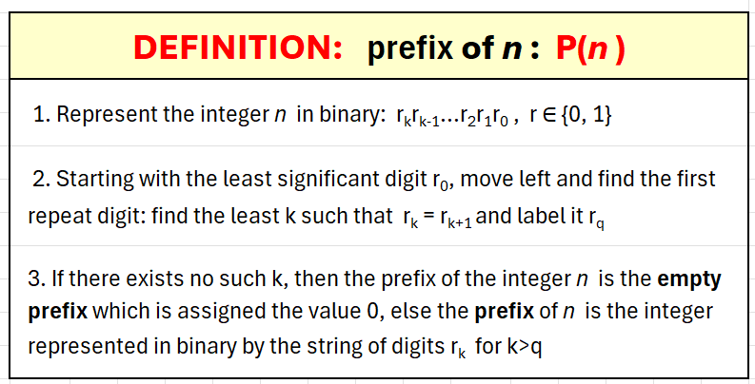
Our ideas begin with these definitions…
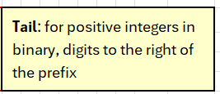
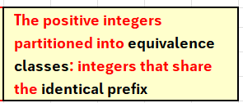
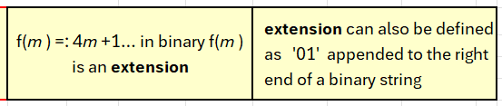

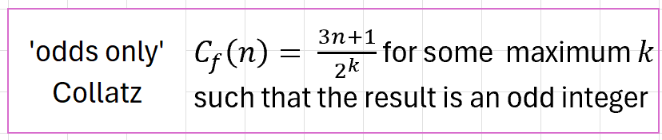

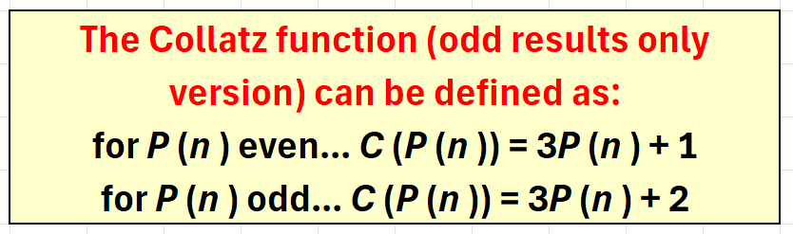
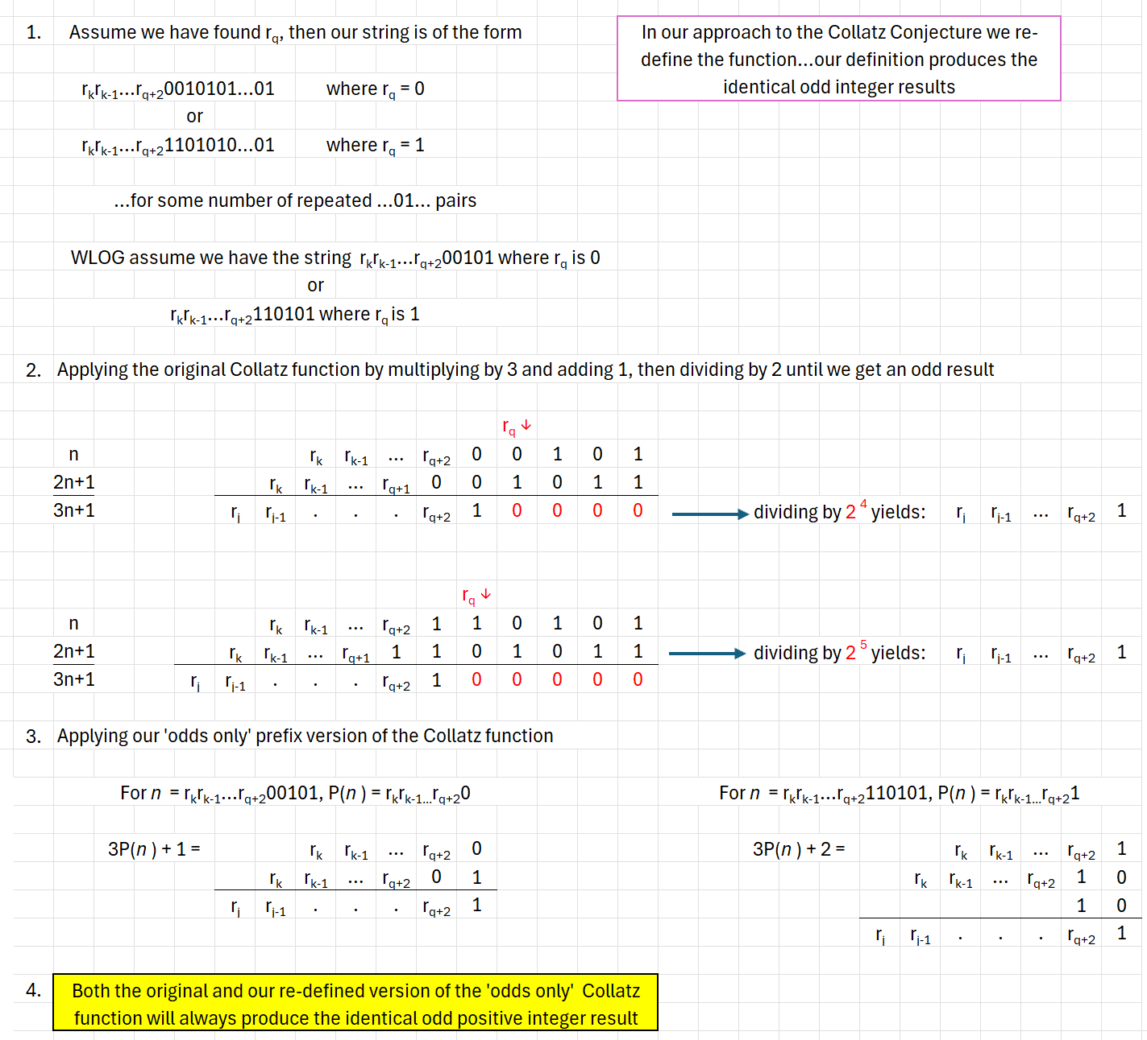
We observe that with these definitions the original ‘odds-only’ version of the Collatz function C_{f} can be re-defined in terms of ‘prefix’…
Since every member of a given prefix equivalence class will by the original Collatz function (C_{f}) produce the identical odd positive integer (OPI) result and thus the identical prefix class result, a proof of the conjecture can be achieved by consideration of the sequence of prefix classes alone. Proving that we can specify the sequence of classes determined by the Collatz function for every OPI is sufficient as a foundation for proof that every integer will eventually descend to the fixed cycle at 1.

We view the Collatz function as operating on infinite prefix equivalence classes of OPI…as an affine function from one prefix class to another. Our reparameterization of the Collatz function provides a relative orientation between prefix classes producing a total order on the set of prefix classes. Relative to a given OPI we can establish an orientation of ‘upward’ and ‘downward’ between classes:
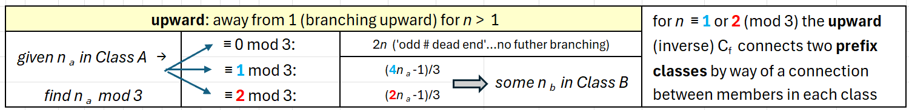
- ‘Upward’ from a given OPI points to a whole infinite class of values in the single, unique prefix class all of whose members return that given OPI as a result of the application of the original Collatz ‘odds-only’ function (C_{f}).
- Though strictly speaking C_{p} operates on prefix classes, upward can be described as ‘1 to many’.
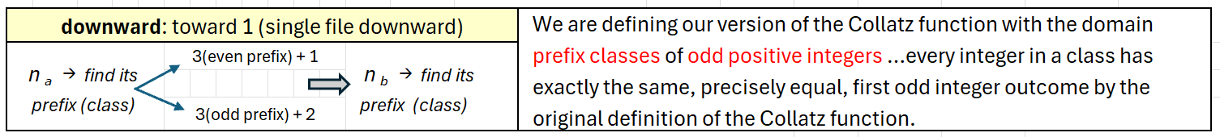
- An OPI determines a class by way of its prefix. We define a class B as ‘downward’ from an infinite class A whose members return a single OPI in that class B as the result of applying the rule …
‘Downward’ produces a sequence of classes and can be described as ‘many to 1’:

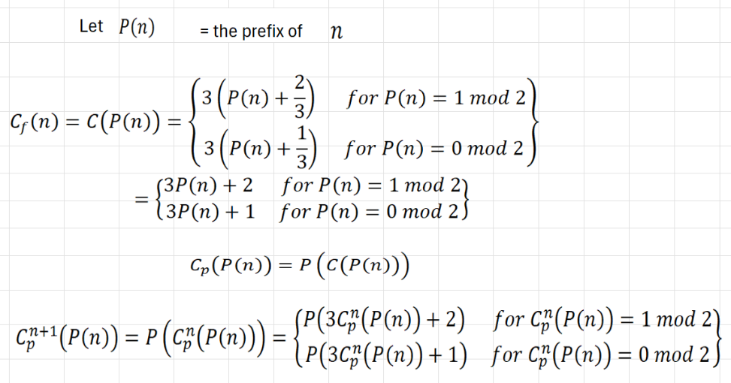
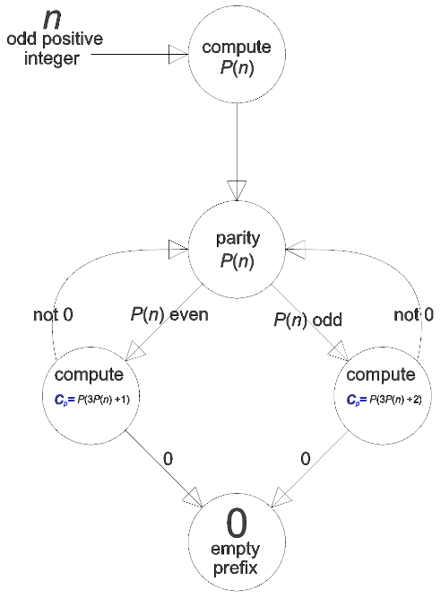

- Individual members of a class are related by the extension function f(m) = 4m+1…each such member has unique upward branching.
- ‘Downward’ is a cascade through prefix classes by way of an affine function applied to integers as prefixes. The downward C_{p} connects individual integers by operating on the prefix that determines a class.
- The looping back to ‘parity’ produces an order on prefix classes

The order of operations in the Collatz function C_{p} (P(n)) = P(C (P(n))) determines a strict hierarchy between integers in three distinct roles.
- As n, an integer in counting order
- As P(n), the prefix of n
- As P(C (P(n))), the prefix of the odd integer result of applying the Collatz function to n
The Collatz function reorders the integers as prefixes in a total order distinct from counting order.
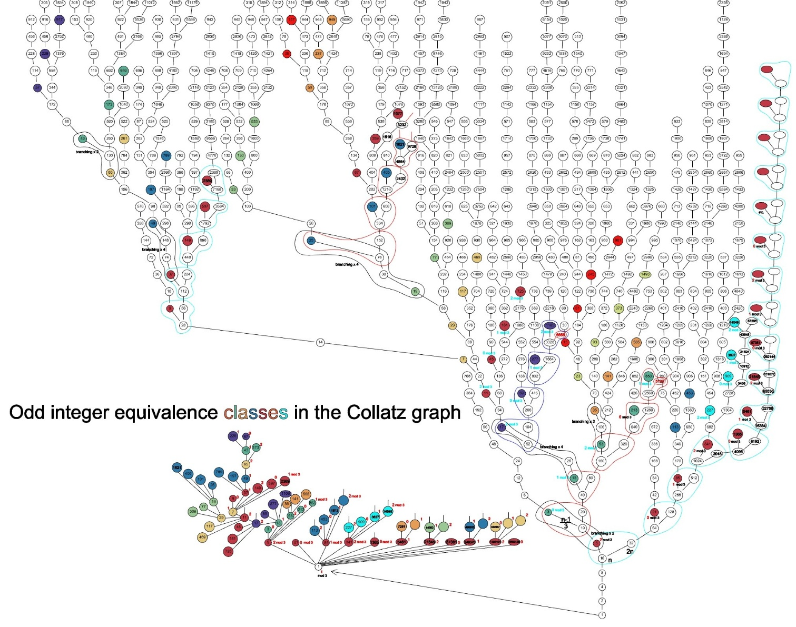
All n that are multiples of 3 are connected to exactly 1 other integer. Every multiple of 3 is the terminal element in the path that connects it to 1. The functions connecting classes are determinate and affine.

Part II
The structures described in Part I have immediate application to producing a coordinate system on the Collatz results.
Because both prefixes and class position (extension number) can be ordered in the usual counting order, we can represent the upward connection between two OPI uniquely by just two coordinates: (prefix, class position)…(p,x). This coordinate scheme produces a total order on the OPI distinct from counting order or the order imposed by branching in the Collatz graph. 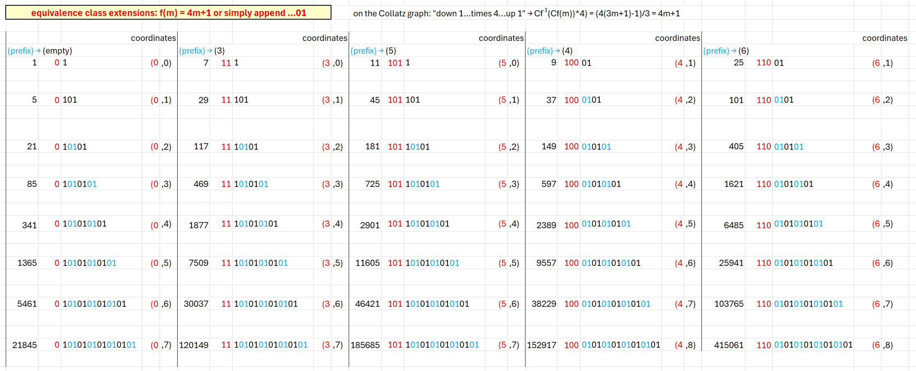
If we label the edges between two integers in the odds-only Collatz graph with the coordinate pair that applies to the upward element, we can then consider the graph directed.
The Collatz function produces a total order on the OPI.

Part III
The prefix of the odd positive integers (OPIs) on the receiving end of an upward connection is the quotient of the division by 3 of the sending OPI. The extension number of the least OPI member of the receiving class is determined by the parity of the quotient by 3 of the sending OPI:
- If the quotient q of the sending OPI divided by 3 is odd, then the least member of the receiving class has prefix q and extension number 0 and is equal to 2q+1
- If the quotient of the sending OPI divided by 3 is even, then the least member of the receiving class has prefix q and extension number 1 and is equal to 4q+1
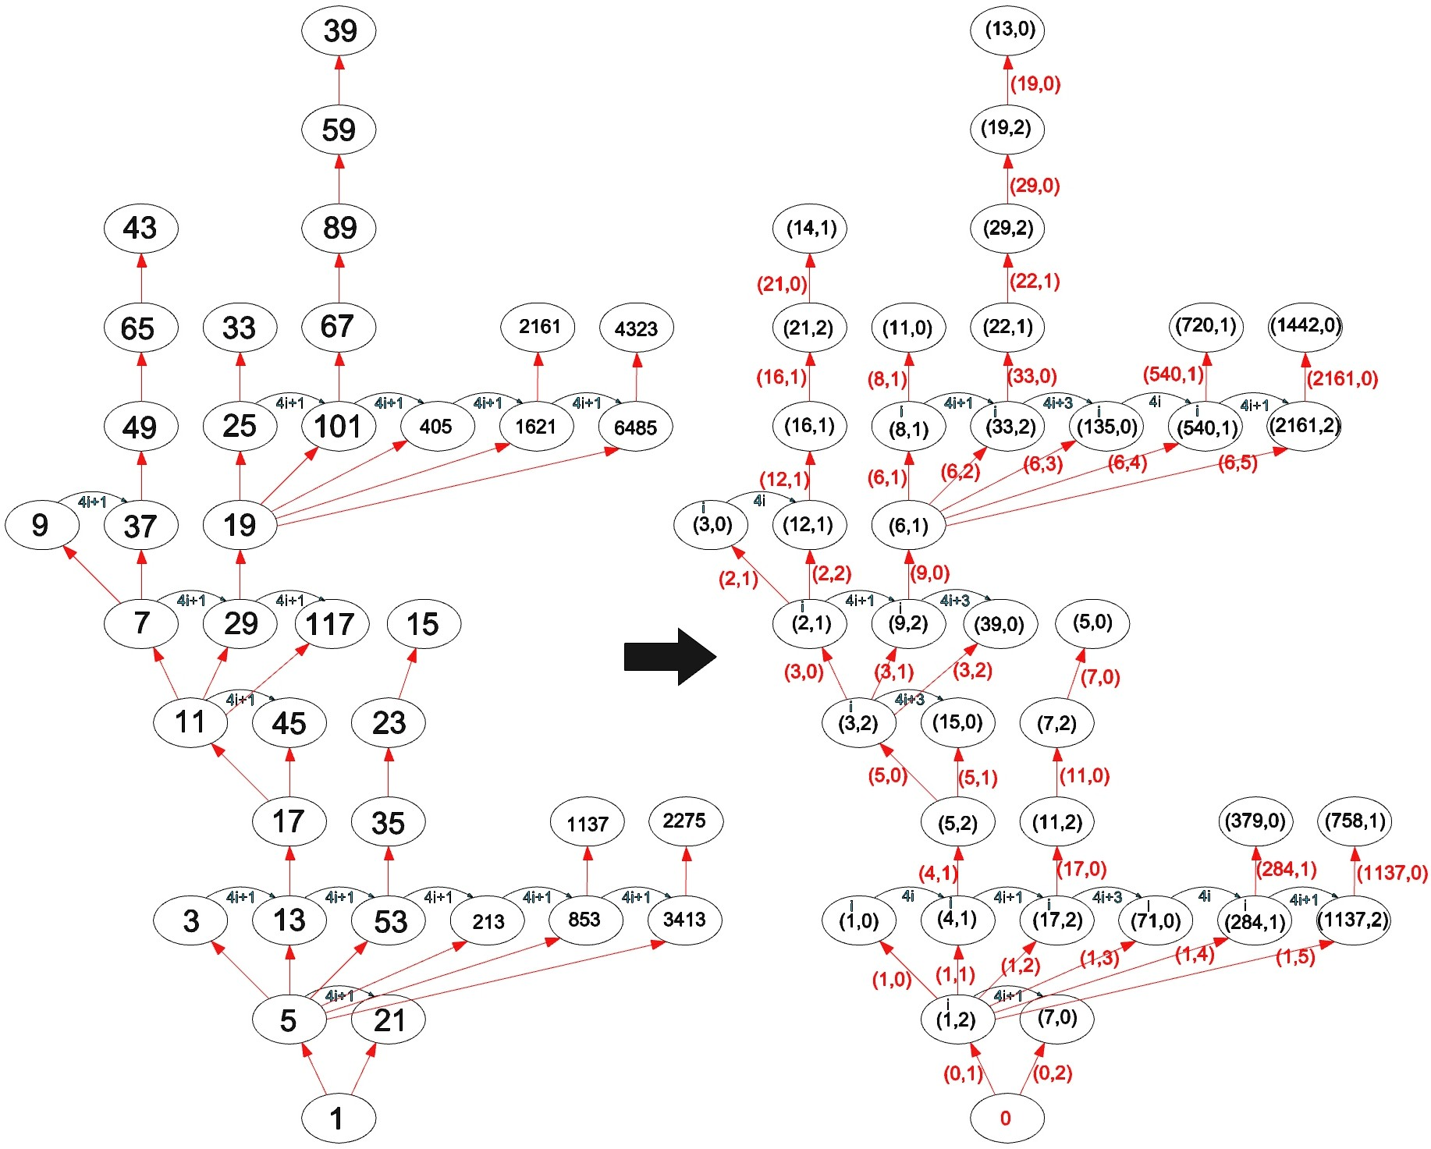
In the diagram below the OPIs are replaced with the coordinate pair (q,r)… (quotient by 3, residue) and the connections are labeled with the coordinate pair (p,x)… (prefix p of receiving class = q of the sending OPI, receiving class extension number x). The functions are affine, the whole structure is completely deterministic.
Note that there are two connections that determine the value assigned to a node that is not a least-in-class node we can eliminate one of them and still have a deterministic structure

Part IV
- Within a class the residues follow a strict order: …012012…
- The least member of each class is determined by the q of the sending OPI in the connection that establishes the class as explained in Part III, 1. and 2. The residue of the least member is, therefore, determined
- All nodes that are OPI ≡ 0 mod 3 are terminal nodes and can be ignored regarding branching. Their removal from each prefix class will change nothing regarding the overall structure of the graph in the upward direction… All unending upward connections will remain and the downward connections of the removed multiples of 3 will follow the connections of any remaining member of the class and in that sense contribute nothing to the question regarding the validity of the Collatz conjecture
- The question regarding the ultimate validity of the Collatz conjecture remains the same
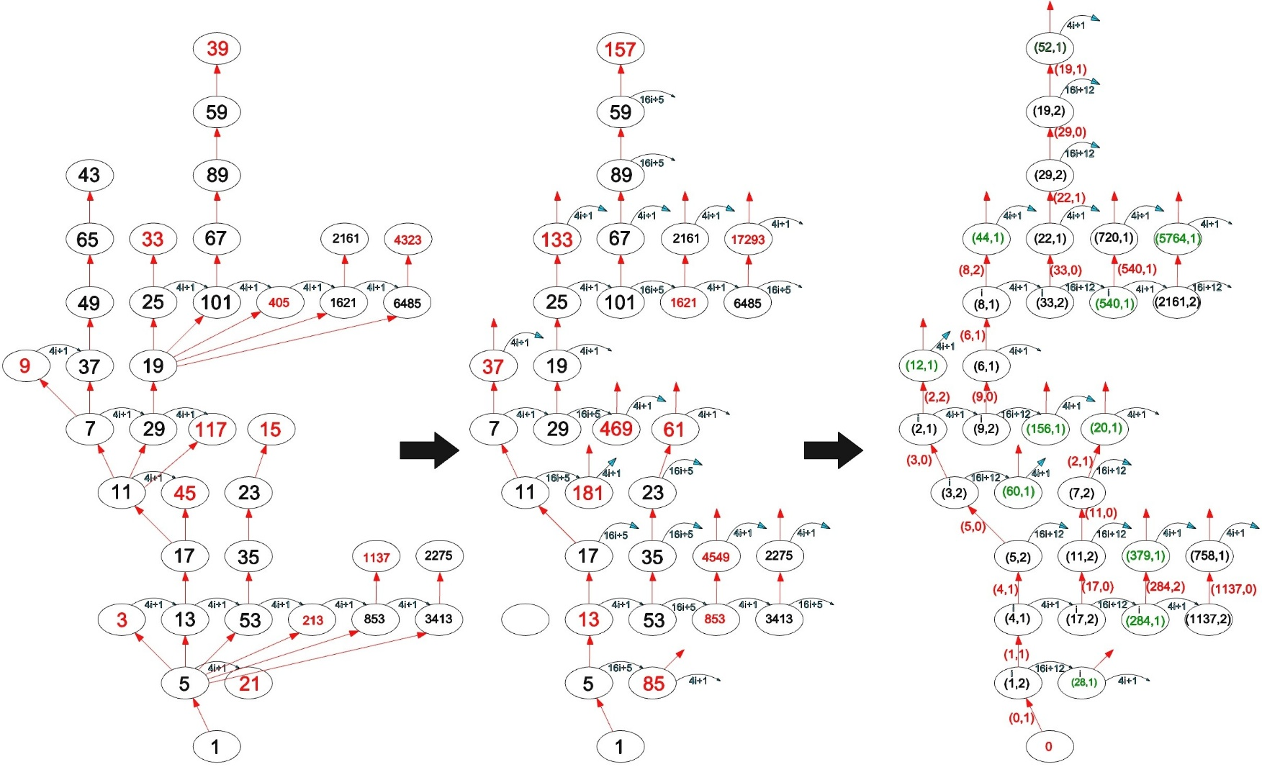
- The affine functions that express the relationship between OPI within a class assigned to nodes after removal of 0 mod 3 members are changed but still deterministic (see the diagram below)
Note that in the leftmost graph there are two connections that determine the value assigned to a node that is not a least-in-class node we can eliminate one of them without a loss of information and transform the odds-only Collatz graph into a perfect infinite binary tree

- Because the connections between members of a class and upward connections are deterministic, we can reduce the number of connections emanating from a given OPI > 1 to exactly two without loss of information regarding the structure and the values of all connected OPI:
  - the upward connection to the least class member not ≡ 0 mod 3 in the receiving class is determined by the sending OPI (q,r)
  - the connection to the next greater member not ≡ 0 mod 3 in its own class is determined by the class prefix and extension number…(p,x)… see the diagram below
- Therefore, we can consider the Collatz graph above 1 as a perfect infinite binary tree
- Every subtree in a perfect infinite binary tree is isomorphic to the whole tree
- In a perfect infinite binary tree every node is the root of a subtree with a countable number of nodes and is connected to the root of the tree
- The tree that includes all members of every class (we assume the presence of the OPI≡ 0 mod 3 in the class adjacent to those ≡ 1 mod 3) includes every possible OPI as a destination of an upward branching… see ARRAYs 1, 2, and 3 presented in the Collatz_Decoded_22-12-2025 Excel spreadsheet
https://21stcenturyparadox.com/wp-content/uploads/2025/12/collatz_decoded_22-12-2025-5.xlsx
- Therefore, every OPI is accounted for in the tree and connected to 1 in the downward direction.

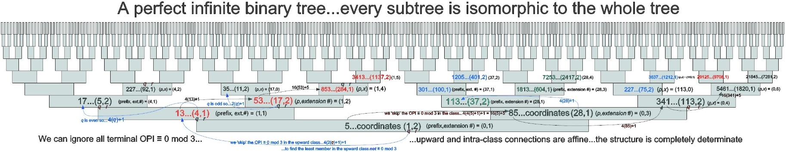

The structure is identical to that of the irrational elements >1 in the extension field $Q\sqrt{5}$ encoded in the Stern-Brocot tree. In that tree between every two integer values to the right of 1 there is a subtree isomorphic to the whole left side (the subtree between 0 and 1). As encoded in the S-B tree every irrational element >1 in the extension field $Q\sqrt{5}$ has a finite prefix and an infinite alternating tail. The right side of the tree is rooted at 1. The structure is hyperbolic.

In the odds-only Collatz graph every downward path from an OPI will eventually reach 1 under iteration of C_{p}
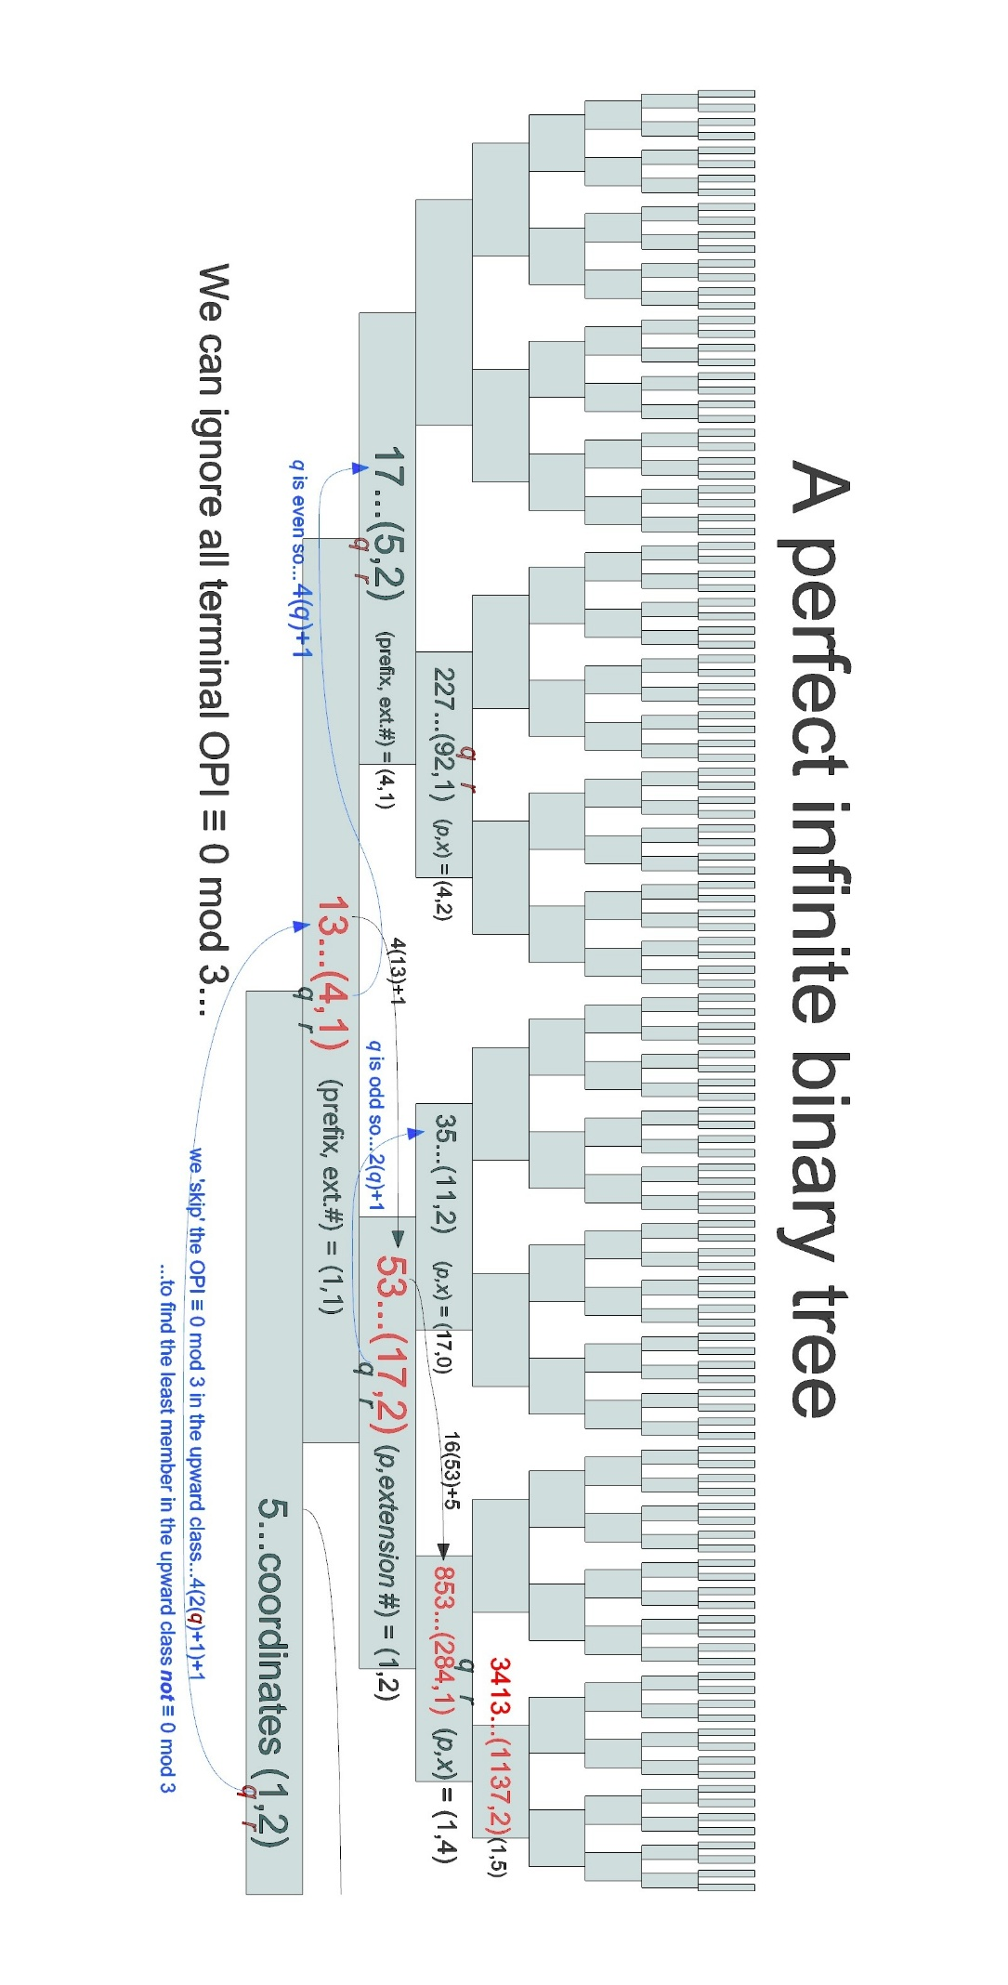
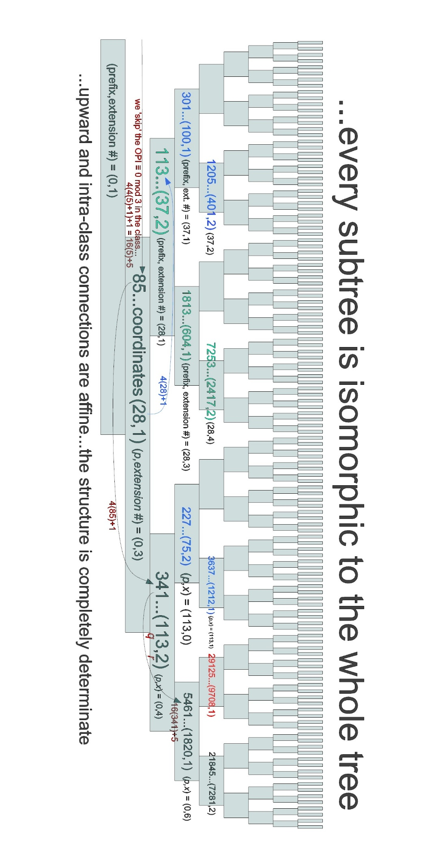
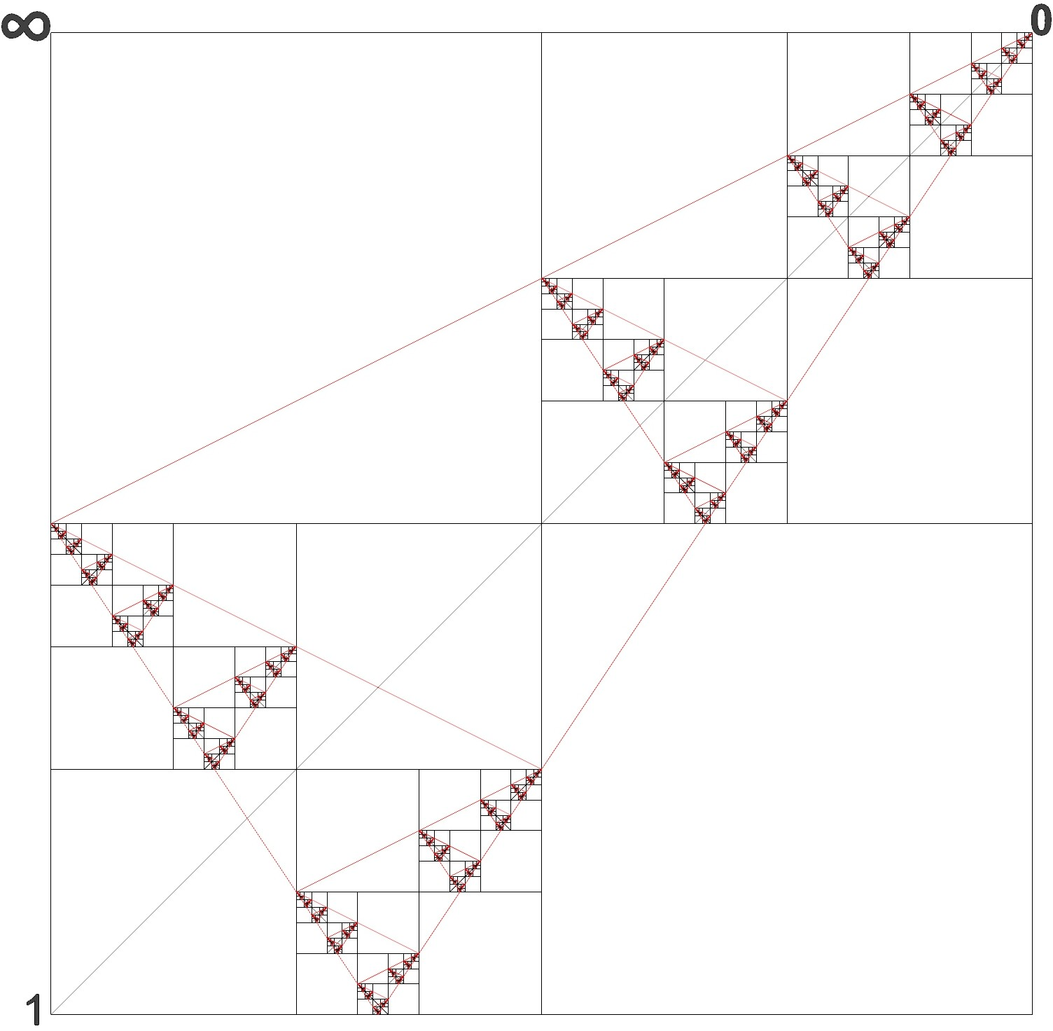
A graphical representation of the field…

