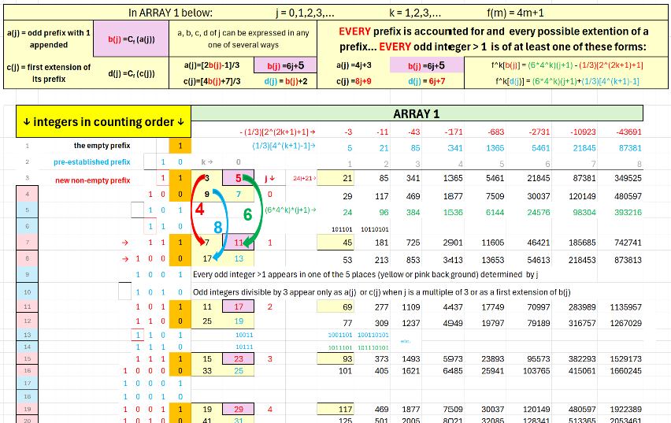
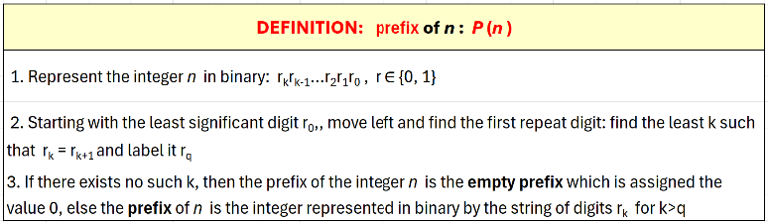
Starting with the column k = 0, the functions…
f^k[b(j)] = (6*4^k)(j+1) - (1/3)[2^(2k+1)+1]
f^k[d(j)] = (6*4^k)(j+1)+(1/3)[4^(k+1)-1]
…generate the rows in the table above. Every odd positive integer not a multiple of 3 appears in one of the rows determined by the two functions.
If we consider the integers determined by the functions for j, k = 0,1,2,3,… as numerators of dyadic fractions with denominator the least power of 2 greater than the numerator and consider each row as a sequence of such fractions, then the limit of each row is well defined.
The (3x+1)/2^k function is a compression of the interval (0,1) by 2/3…
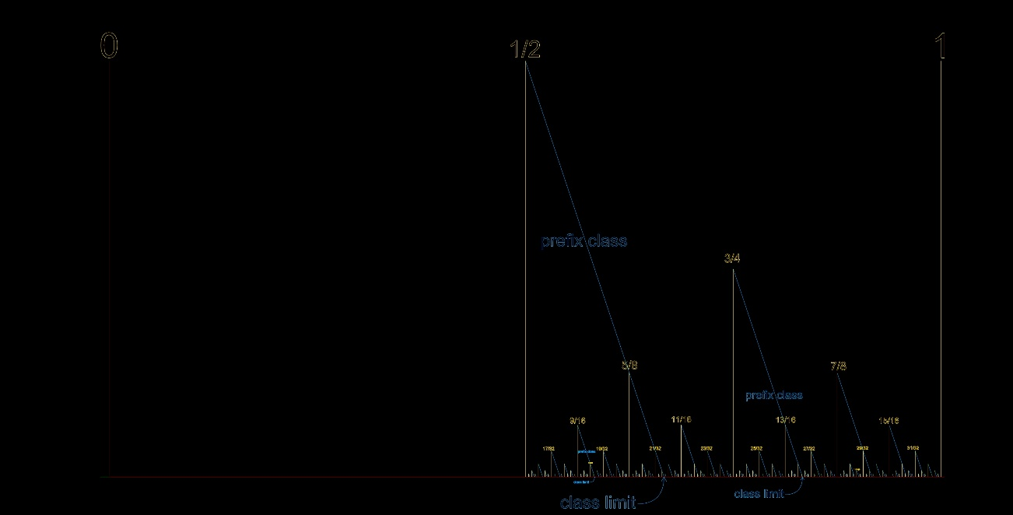
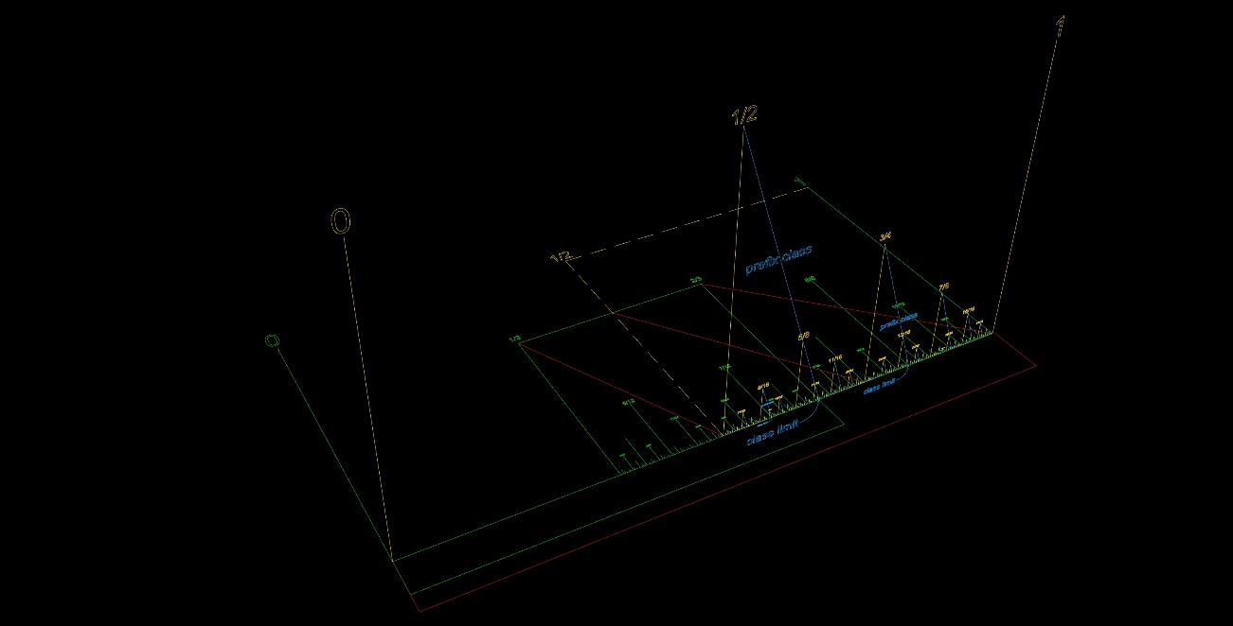
…the blue segments in the vertical plane connect values in a single prefix class (row)…
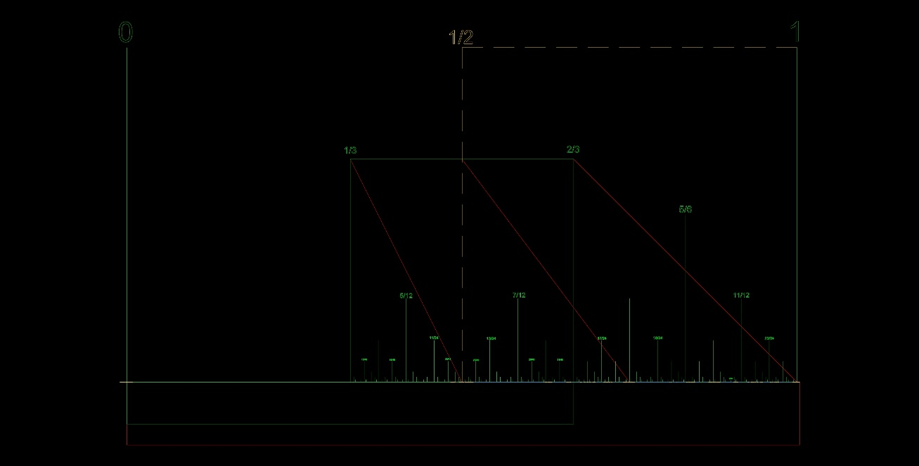
…the green segments in the horizontal plane are the values of class (row) limits…

f^k[b(j)] = (6*4^k)(j+1) - (1/3)[2^(2k+1)+1]
f^k[d(j)] = (6*4^k)(j+1)+(1/3)[4^(k+1)-1]
For a given j (a given row) the limit of each of the two functions

as k → ∞ is the limit value for that row (class). The limit of each row is equal to a fraction 2/3rds the value of the integer produced by the (3x+1)/2^k function acting on the element in column k=0 in each row.
The limit value for both functions as j and k → ∞ is ¾.
The (3x+1)/2^k function is a compression by 2/3 of the interval (0,1).
The result is a perfect infinite binary tree that contains every odd positive integer…
